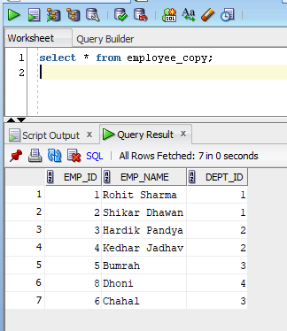

Difference is Dhoni

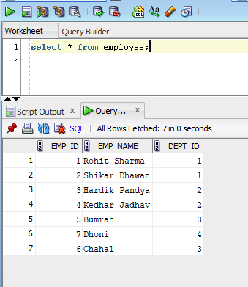

**Union**

UNION operator is used to combine the result sets of two or more Oracle SELECT statements. It combines the both SELECT statement and removes duplicate rows between them.

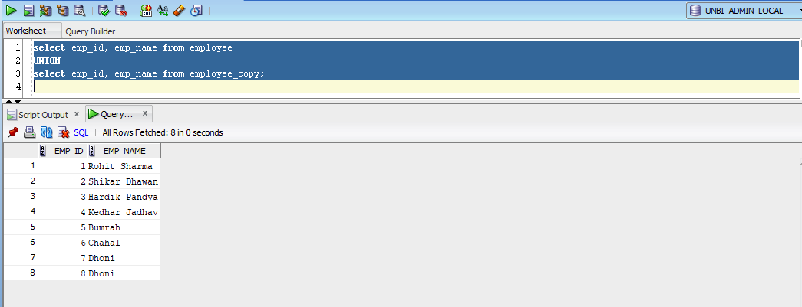

**Union All**

In Oracle, the UNION ALL operator is used to combine the result sets of 2 or more SELECT statements. It is different from UNION operator in a way that it does not remove duplicate rows between the various SELECT statements. It returns all of the rows.

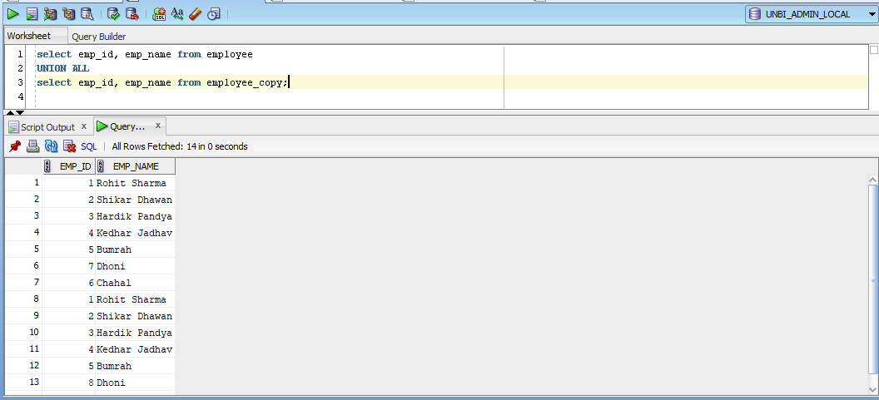

**Intersect**

INTERSECT Operator is used to return the results of 2 or more SELECT statement. It picks the common or intersecting records from compound SELECT queries

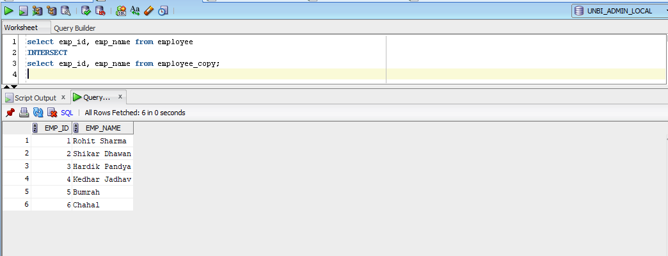

**Minus**

MINUS operator is used to return all rows in the first SELECT statement that are not returned by the second SELECT statement.

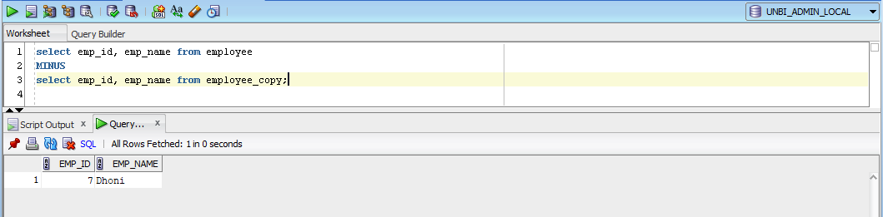

**Joins**

Oracle JOINS are used to retrieve data from multiple tables. An Oracle JOIN is performed whenever two or more tables are joined in a SQL statement.

* Inner Joins (Simple Join)
* Outer Joins
* Left Outer Join (Left Join)
* Right Outer Join (Right Join)
* Full Outer Join (Full Join)
* Equijoins
* Self Joins
* Cross Joins (Cartesian Products)
* Antijoins
* Semijoins

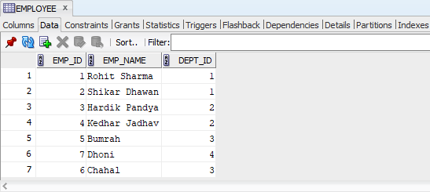

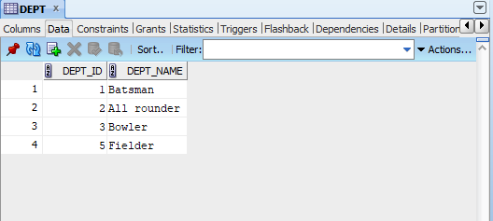

**INNER JOIN (simple join) or JOIN**

Oracle INNER JOINS return all rows from multiple tables where the join condition is met.

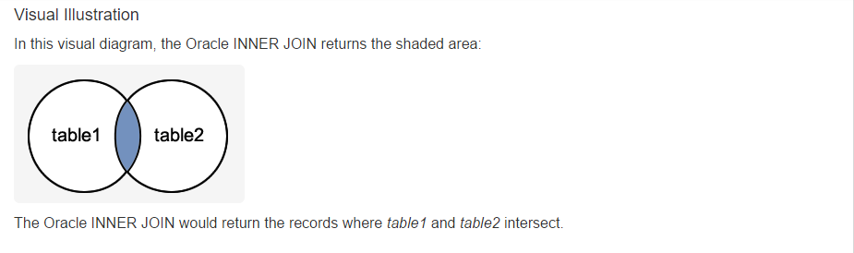

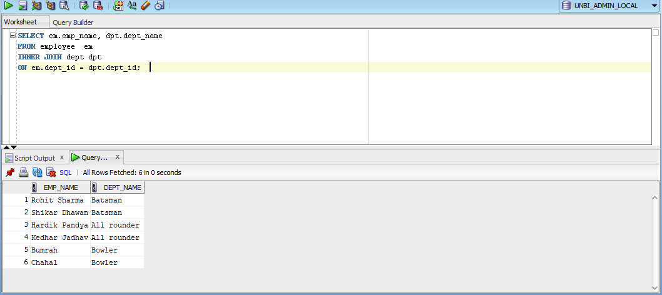

**LEFT OUTER JOIN**

Another type of join is called an Oracle LEFT OUTER JOIN. This type of join returns all rows from the LEFT-hand table specified in the ON condition and only those rows from the other table where the joined fields are equal (join condition is met).

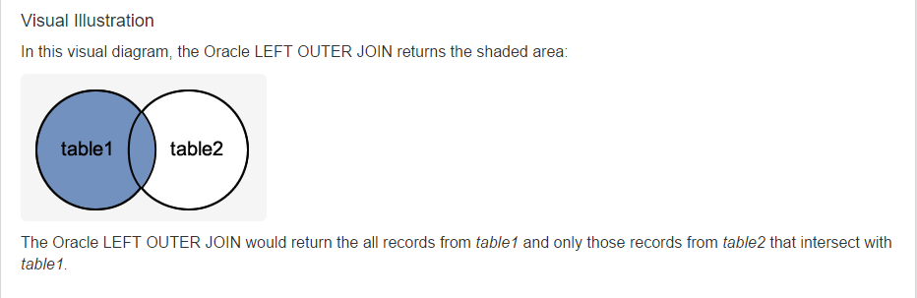

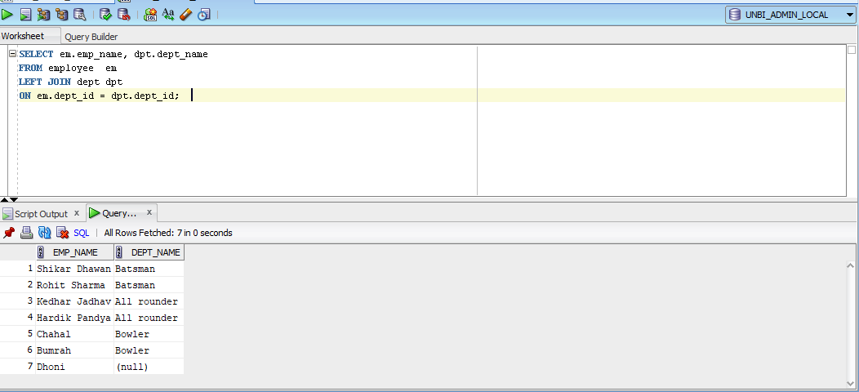

**RIGHT OUTER JOIN OR RIGHT JOIN**

Another type of join is called an Oracle RIGHT OUTER JOIN. This type of join returns all rows from the RIGHT-hand table specified in the ON condition and only those rows from the other table where the joined fields are equal (join condition is met).

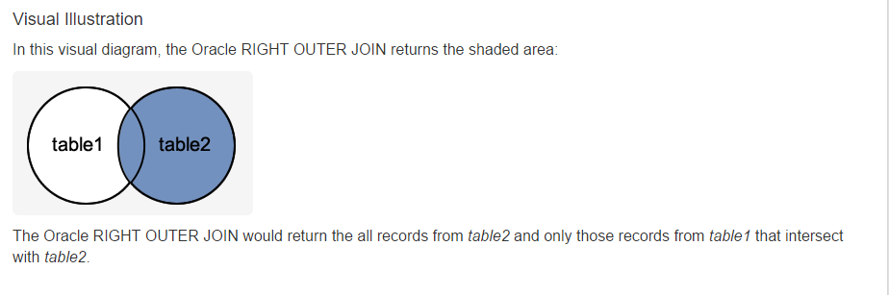

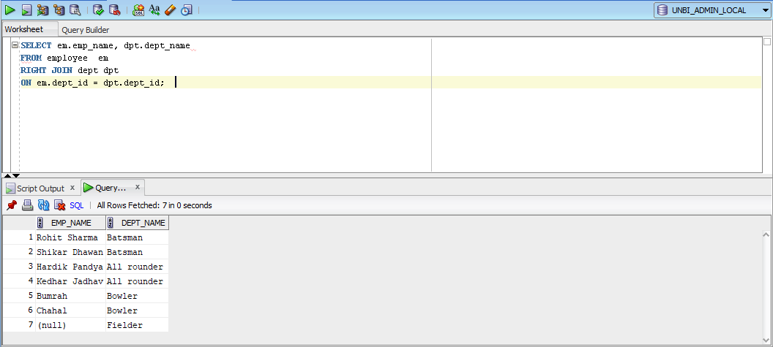

**FULL OUTER JOIN or FULL JOIN**

Another type of join is called an Oracle FULL OUTER JOIN. This type of join returns all rows from the LEFT-hand table and RIGHT-hand table with nulls in place where the join condition is not met.

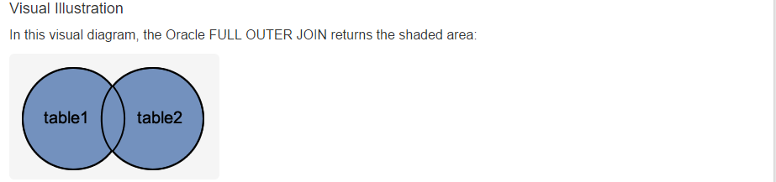

**CROSS JOIN**

The CROSS JOIN clause produces the cross-product of two tables. A cross join or Cartesian product is formed when every row from one table is joined to all rows in another. Suppose, the source and target tables have four and three rows, respectively, a cross join between them results in (4 × 3 = 12) rows being returned provided by there is no WHERE clause have been applied with the cross join statement.

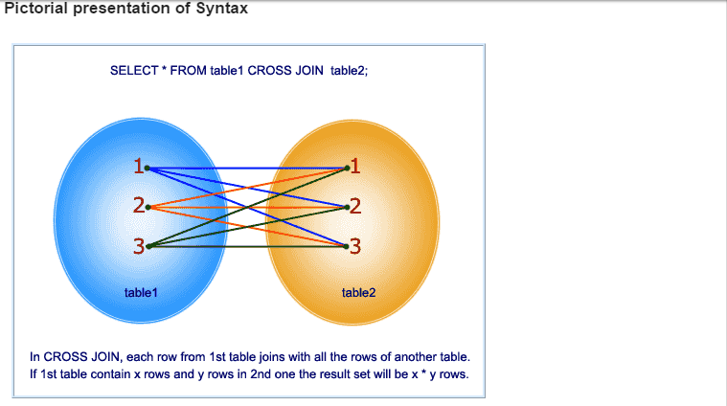

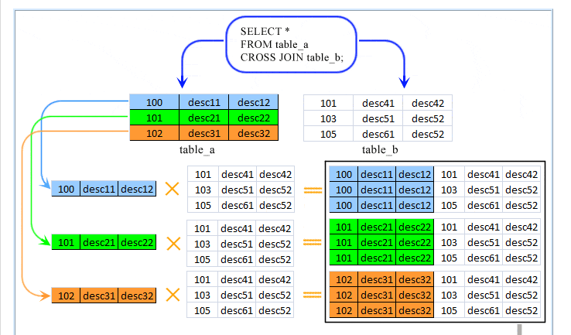

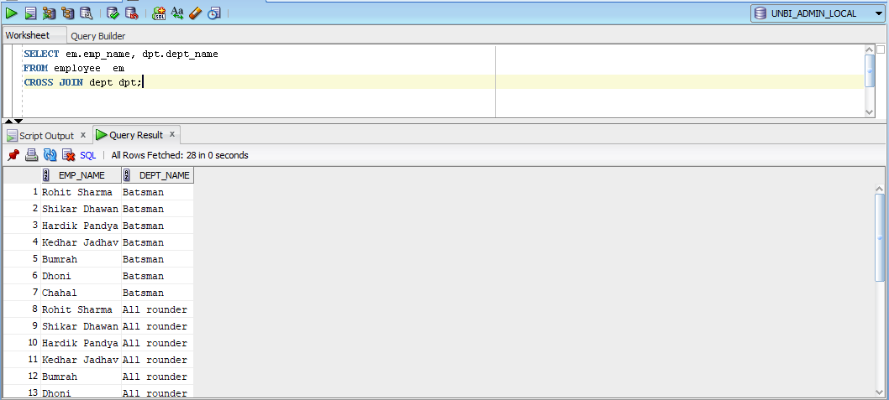

**SELF JOIN**

A self join is a join in which a table is joined with itself.

To join a table itself means that each row of the table is combined with itself and with every other row of the table.

The table appears twice in the FROM clause and is followed by table aliases that qualify column names in the join condition.

The self join can be viewed as a join of two copies of the same table. The table is not actually copied, but SQL performs the command as though it were.

To perform a self join, Oracle Database combines and returns rows of the table that satisfy the join condition

EMPLOYEES TABLE

